SANA3 | صانع
Learn by Building
Founder's Brief: Vision, Pedagogy, Organization & Partnership Structure
Prepared for internal founder / co-founder use
7 August 2026

Part 1 — The SANA3 Vision, Illustrated
This section restates the four foundational documents in the voice of the CEO — the story to tell a parent, a school, an investor, or a new instructor — with a diagram under every core structural idea so it can be presented, not just read.

1. Vision
In 10 years, “made by SANA3” means a young person who can take an idea from a napkin sketch to a working, shippable piece of technology — and defend every decision inside it.
SANA3 exists to make that capability common instead of rare. Today it lives in a small population of self-taught kids with unusual access to mentors and hardware. Our job is to manufacture that capability deliberately, at scale — starting in Egypt, expanding across the Gulf and beyond.

2. Mission — Four Components, Not One
Every graduate must be able to understand a problem, design a solution, build the product, and launch it. Drop any one of the four and it is not a SANA3 outcome — it's just a course completion.
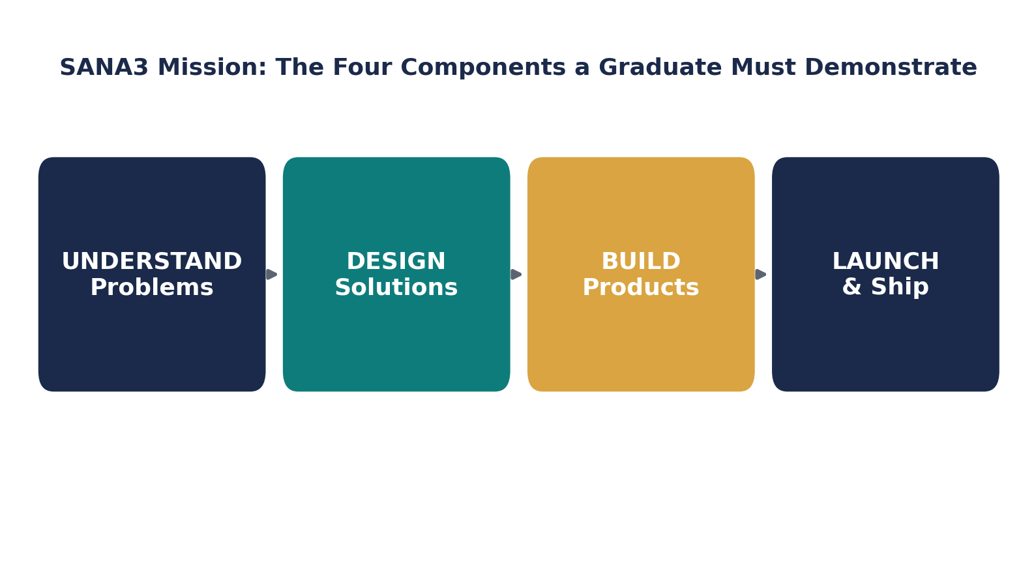
Figure 1 — The four components a SANA3 graduate must demonstrate together
Component | What it means | What it is NOT
Understand | Turn an ambiguous situation into defined requirements | Solving pre-packaged exercise prompts
Design | Propose an architecture, justify trade-offs | Copying a tutorial's structure blindly
Build | Implement, test, integrate into something that runs | Passing isolated coding-quiz questions
Launch | Ship, present, deploy, or compete | Treating “finishing the course” as the finish line

3. Brand Positioning
SANA3 is a software and technology building education platform for the next generation — not a coding academy for kids.
“Coding academy” signals syntax transfer, competing on price and course catalog. “Building education platform” signals an outcome — capability and portfolio — competing on results. Every brand decision should protect that distinction.

How I'd say it to each audience
Audience | The pitch
Parent | Your child won't just learn to code — they'll build real things they can show you, and get better at solving problems on their own.
School (B2B) | A structured, assessable STEM/CS program you can adopt without building curriculum in-house.
Investor | A differentiated, IP-defensible pedagogy plus a portfolio-based credential that's more legible than a certificate.
Future instructor | You'll be a Learning Engineer, not a lecturer — mentoring real builds, not repeating a slide deck.
Primary tagline: “Learn by Building.” B2B/investor line: “From Idea to Product.” Internal culture line: “Build to Learn.”

4. Educational Philosophy — the one design decision everything else follows from
We don't teach technology first. We teach students to build with technology. Learn because you need it. Build because you learned it.
The instructor never opens with “Today we are learning variables.” Instead, the need is felt first and the concept is named second:
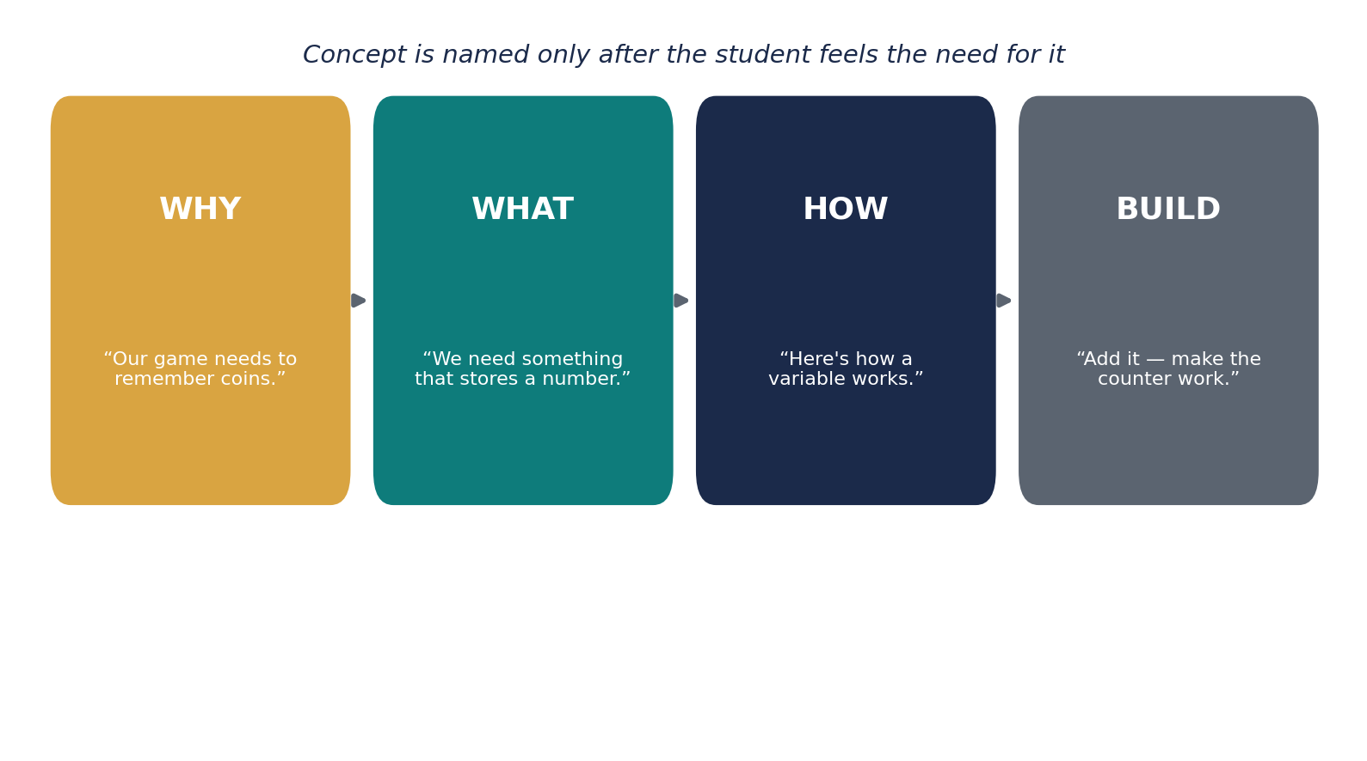
Figure 2 — WHY → WHAT → HOW → BUILD: concepts are named after the need is felt
This ordering is the single most important instructor discipline in SANA3 — and the opposite of how most instructors were themselves taught to teach.

Seven questions a student should always be able to answer
- What are we building?
- Why does this feature matter?
- What problem are we solving?
- What knowledge do we need?
- What did I learn?
- How did I use it?
- Can I use it somewhere else?
Can't answer 1–3 → the session drifted into topic-first teaching. Can't answer 5–7 → the session produced activity without learning.

5. The Learning Framework — one loop, four time-scales
Every class is a small Learning Cycle. String cycles together and you get a Mission. String Missions together and you get a shipped Feature. String Features together and you get a shipped Project. Nothing at any scale breaks from the same shape — only the granularity changes.
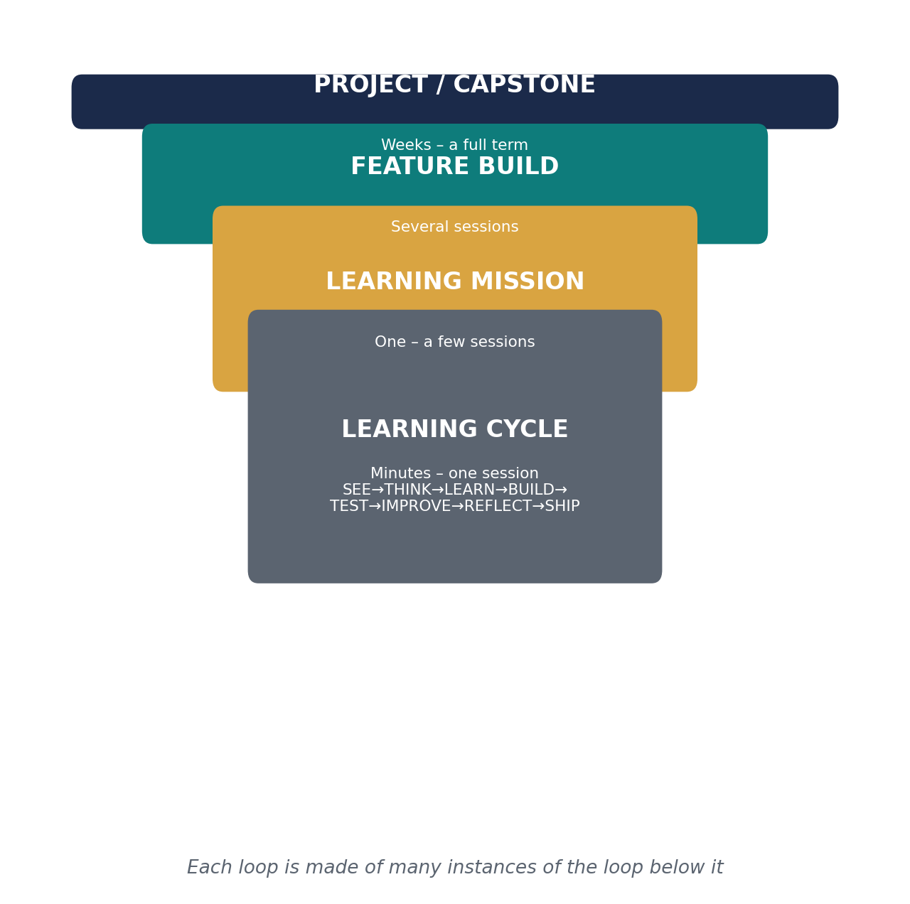
Figure 3 — The four nested loops, session to capstone

The Learning Cycle in detail
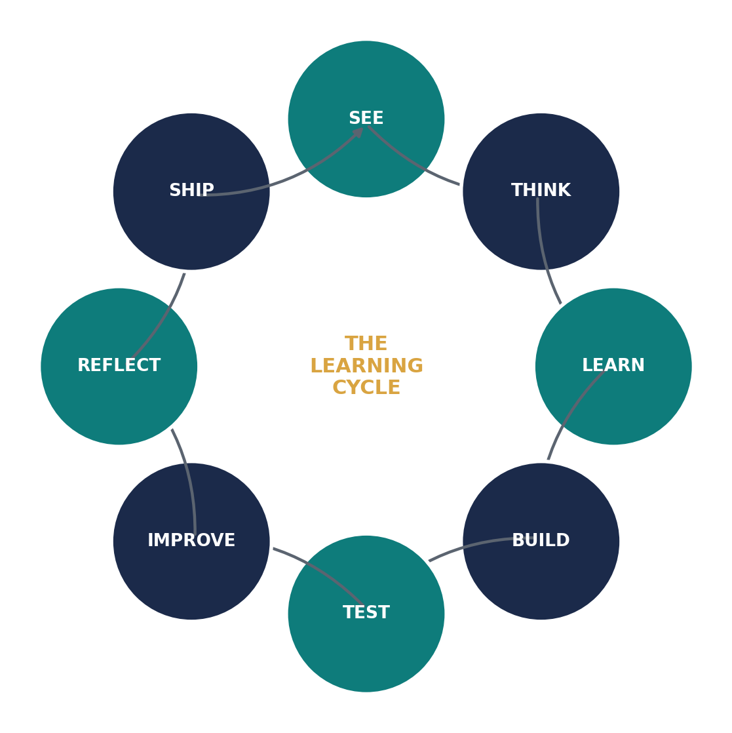
Figure 4 — SEE → THINK → LEARN → BUILD → TEST → IMPROVE → REFLECT → SHIP

Two progressions that must move in lockstep
As a student moves from Follower toward Creator, the instructor must move from “I do” toward “you teach” at the same pace. An instructor still doing “I do” with a student ready for independence is a coaching flag, not a scheduling detail.
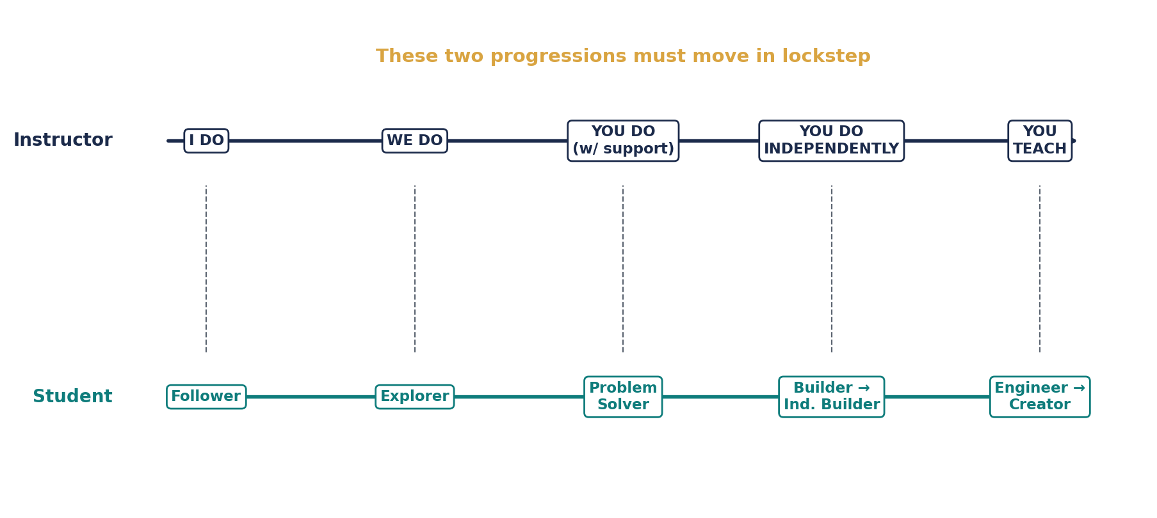
Figure 5 — Instructor gradual release vs. student identity arc

6. What Actually Differentiates SANA3
Not which technologies we teach — most competitors touch Scratch, Python, Arduino, robotics too. It's the sequencing logic: project pulls knowledge, not knowledge pulls project. Concretely:
- Every program starts with a Project Reveal, not a syllabus
- Curriculum is a feature → knowledge graph, not a linear course list
- Assessment is a living Student Passport, not a completion certificate
- Software, Embedded, IoT, Robotics and AI share one pedagogy, not siloed tracks
- Competitions are core curriculum, not an optional extracurricular

What we deliberately trade away
A knowledge-on-demand curriculum can leave gaps if no project happens to need a foundational concept — mitigated by an Anchor Knowledge checklist per stage. It's harder to staff and schedule than a fixed syllabus — mitigated by a tight Session Framework and Instructor Playbook. And it will look slower than a syllabus competitor if measured by topics-per-month; it should look faster measured by “can this student build something new, alone.”

Part 2 — Organizational Structure
Built to answer the brief you gave: start from the idea-holder + investing partner, and lay out the roles that get added as the company expands past the Menoufia pilot — without redesigning the structure each time.
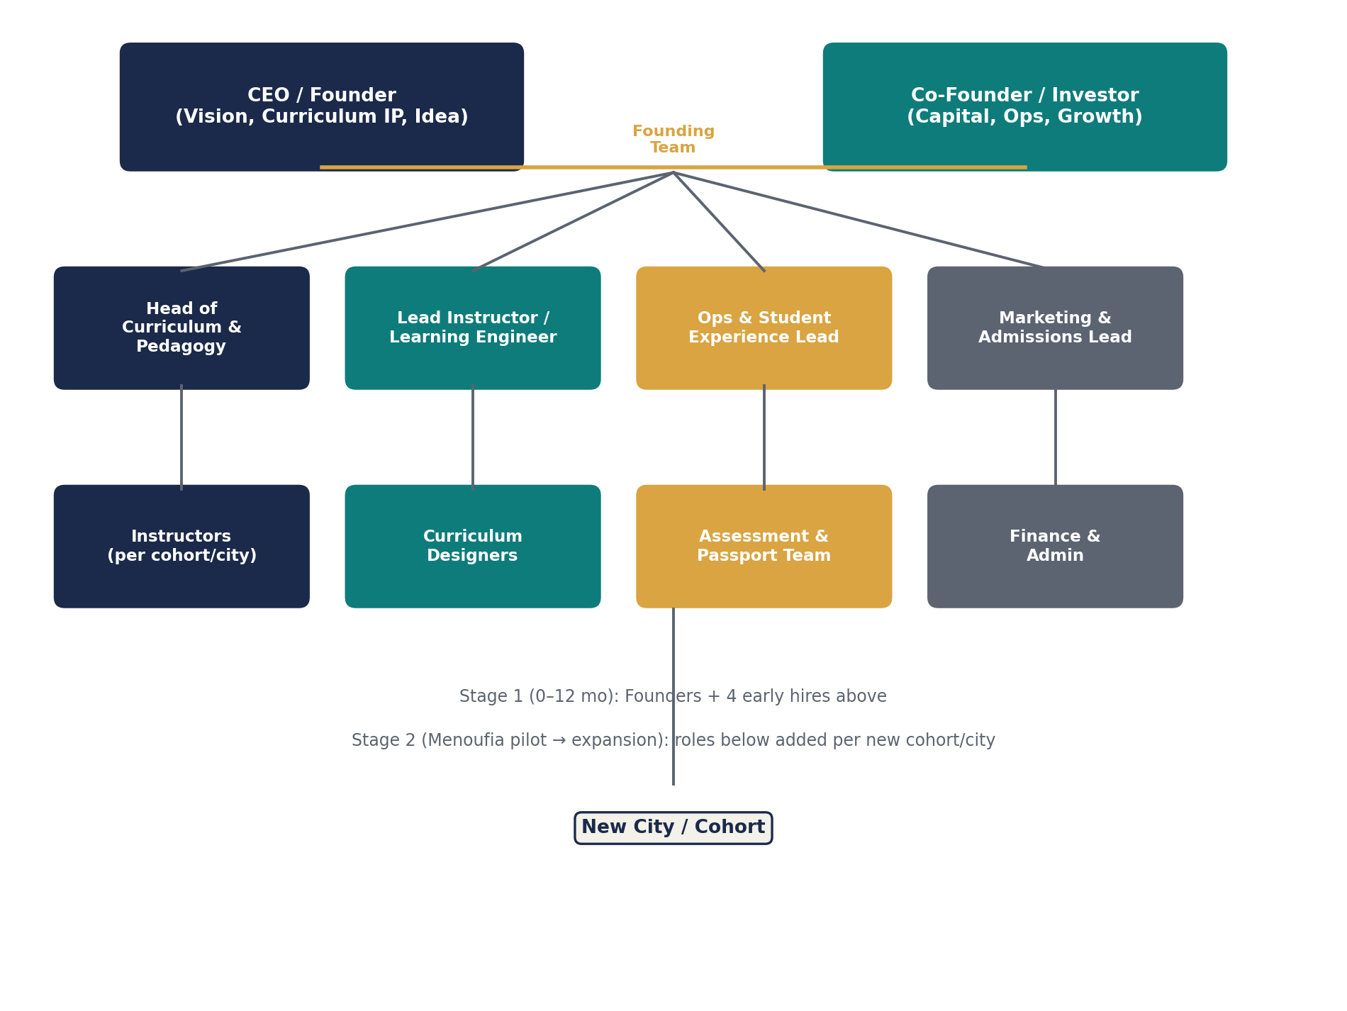
Figure 6 — Founding team → first hires → expansion roles

How to read it
- Top: the two founders. One holds the vision, curriculum IP, and the original idea (CEO). One brings capital and typically owns Ops/Growth day-to-day (Co-Founder).
- Stage 1 (roughly first 0–12 months): four functional leads — Curriculum & Pedagogy, Lead Instructor/Learning Engineer, Ops & Student Experience, Marketing & Admissions. This is the minimum team to run one real pilot cohort properly.
- Stage 2 (post-pilot expansion): each Stage 1 lead grows a small team under them — instructors per new cohort/city, curriculum designers, an assessment/passport team, finance & admin — so the shape scales by adding depth under existing functions rather than inventing new top-level boxes.
Keep it this flat for as long as possible. The two most common failure modes at this stage are (1) hiring management layers before there is a pilot to manage, and (2) letting the investing partner default into a vague “co-CEO” role instead of an owned function — decide explicitly which functions each founder owns from day one, in writing.

Part 3 — Partnership & Equity Structure
You bring the idea, the curriculum design, and (presumably) the early full-time work. Your partner is proposing to invest 20,000 EGP. Below is the factual framework for thinking about the split — not a specific recommendation, since the right number depends on facts only you have (valuation, roles going forward, how much of your own time/money is already in). This is general information, not legal or financial advice — have a lawyer draft the actual shareholder agreement, especially for a formal Egyptian company (e.g. an LLC / ش.ذ.م.م).

1. The core question: is 20,000 EGP buying equity, or is it a loan?
- Straight equity: your partner permanently owns a % of the company in exchange for the cash. Simple, but hard to undo if the relationship or contribution doesn't work out.
- Convertible note / SAFE-style instrument: the 20,000 EGP is a loan (or a right to future equity) that converts to shares later, usually at a discount, once there's a priced round or a trigger event. Common when the company's value is too uncertain to price fairly today.
- Salary/consulting instead of equity: if your partner's ongoing contribution is mostly capital, not full-time work, some founders prefer to keep equity concentrated in the operating founder and pay the investor back with a return (interest, profit share, or a fixed multiple) rather than permanent ownership.

2. If it is equity — the standard way to size it
The usual approach is a pre-money valuation: you and your partner agree what the company is worth before the cash goes in, then:
Investor's equity % = Investment ÷ (Pre-money valuation + Investment)
Illustrative only — not a valuation of your company:
If pre-money valuation is… | 20,000 EGP buys roughly…
80,000 EGP | 20% (post-money 100,000 EGP)
180,000 EGP | 10% (post-money 200,000 EGP)
380,000 EGP | 5% (post-money 400,000 EGP)
At a true pre-idea, pre-revenue stage there is no market price — the number is a negotiation, not a calculation. What usually justifies a lower valuation (more equity for less cash) is: no pilot yet, no revenue, high execution risk. What justifies a higher valuation (less equity for the same cash) is: a working pilot, a validated curriculum, initial enrollments, or IP already built — all things your Document 01–04 pedagogy work already represents as value you're contributing pre-money.

3. Idea + sweat equity vs. cash — how founders usually weigh it
A common founder heuristic (popularized by tools like the “Founders' Pie Calculator” and “Slicing Pie”) is to price each contribution type separately rather than debate a single number in the abstract:
- Idea alone is usually weighted low — ideas are cheap; execution is what's scarce.
- Full-time, ongoing work (building the curriculum, teaching, running the pilot) is usually weighted highest, because it's the input most likely to determine whether the company survives.
- Cash at the pre-seed stage is real and necessary, but typically buys less equity per pound than an equivalent amount of full-time founder work, precisely because cash is more replaceable than a working product.
If you are working on SANA3 full-time (or near it) and your partner is not, that asymmetry is normally the single biggest factor pulling the split toward you — more than the idea itself.

4. Protect both sides regardless of the split you land on
- Vesting: standard practice is 4-year vesting with a 1-year cliff for both founders' equity — including yours. This protects the company if either person leaves early, and signals seriousness to any future investor.
- Written founder/shareholder agreement: even at 20,000 EGP, put the split, roles, decision rights, and what happens if one person leaves in writing before the money moves.
- IP assignment: make sure the curriculum, brand, and any code/documents (like Documents 01–04) are explicitly assigned to the company, not left as your personal property, so the equity you're both getting is equity in something the company actually owns.
- Decide governance separately from equity: equity % doesn't have to equal voting control or who has final say on curriculum vs. spending — those can be set explicitly in the agreement regardless of the ownership split.

5. A concrete next step
Pick a pre-money valuation you can both defend in one sentence (e.g. “we're valuing the pre-pilot curriculum and brand at X EGP because…”), run it through the formula above, then sanity-check the result against how much ongoing time each of you is actually putting in. If you can't agree on a valuation yet, the convertible-note route lets the 20,000 EGP go in now and the equity conversation happen later, once the Menoufia pilot gives you real numbers to price it with.

Part 4 — Co-founder Split & Investor Profit Models (Worked Example)
This section applies the Part 3 framework to your actual situation: an operating co-founder (full-time, owns the Ops function, also investing 20,000 EGP) and, separately, the possibility of a silent third-party investor. As before, this is a starting framework to negotiate from, not a fixed answer — the right numbers depend on facts only you and your co-founder have.

1. You ↔ Operating Co-founder
Since you're both full-time, this isn't “idea vs. money” anymore — it's two full-time contributors, one of whom also originated the idea and curriculum IP and is putting in cash on top. A simple weighted way to reach a defensible number:
Contribution factor | Weight | You get | Co-founder gets
Original idea + curriculum IP (Docs 01–04) | 17.5% | 17.5% | 0%
Full-time ongoing work (assumed equal effort) | 50% | 25% | 25%
Cash invested (20,000 EGP, co-founder only) | 10% | 0% | 10%
Risk taken / domain role (CEO vs. Ops) | 25% | 12.5% | 12.5%
Total | 100% | ~55% | ~45%
That lands close to even, tilted slightly toward you for the idea and IP — normal when both people work full-time. Founders typically round this to a clean number like 55/45 or 60/40 rather than using the decimal. There is no single correct split; this shows why a small tilt toward you is defensible even though your co-founder is contributing real cash and real work.
Whatever number you land on: apply 4-year vesting with a 1-year cliff to both stakes. That protects the split if either of you leaves in year one.

2. Silent / Third-Party Investor (No Operational Role)
This is a genuinely different relationship from the co-founder split above, and it can be structured two ways:

Model A — Equity (they own a piece forever)
- Ownership % = Investment ÷ (Pre-money valuation + Investment). Example: 20,000 EGP into a company valued at 180,000 EGP pre-money → ~10% ownership.
- Their profit = that % of any future dividends/profit distributions, plus that % of the sale price if the company is ever sold — for as long as they hold the shares, however large the company grows.
- Upside is uncapped for them; downside is they can end up with 10% of nothing if it fails.

Model B — Loan / Fixed Return (they get paid back and walk away)
- Treat the 20,000 EGP as a loan, not equity: principal back plus an agreed fixed return — e.g. 1.5x–2x their money within 2–3 years, or a stated interest rate, paid from profits or revenue.
- Once repaid, they have zero further claim on the company — no ownership, no upside if you grow large, no say in decisions.
- Lower risk, lower reward for them; keeps 100% of the equity between you and the operating co-founder.
 | Equity model | Loan / fixed-return model
What they get | % ownership forever | Money back + fixed return, then done
Upside if you succeed big | Uncapped | Capped at the agreed multiple
Downside if you fail | Can lose it all | Same, but no dilution if you do succeed
Dilutes future rounds | Yes | No
Best when | You want a long-term backer, not just cash | You want cash without giving up permanent ownership

A common middle ground for a small check (~20,000 EGP)
Give them a profit-share instead of equity — e.g. 20% of net profit until they've received 2x their money back (40,000 EGP), then it either stops entirely or drops to a small permanent trailing % (2–3%). This avoids diluting the cap table for a relatively small amount while still rewarding early risk.
Either way, define “profit” in writing as net profit after costs and founder salaries, not revenue — undefined “profit share” language is the most common source of later disputes. And since real money is changing hands, get a one-page signed agreement before it does; the actual contract language, especially once the company is formally registered, is worth 30 minutes with a lawyer.

